1.5 Surface Area for Solids of Revolution

General Idea:
When a curve is revolved to form a solid we can try to determine the resulting solid’s lateral surface area (surface area excluding the bases of the figure).

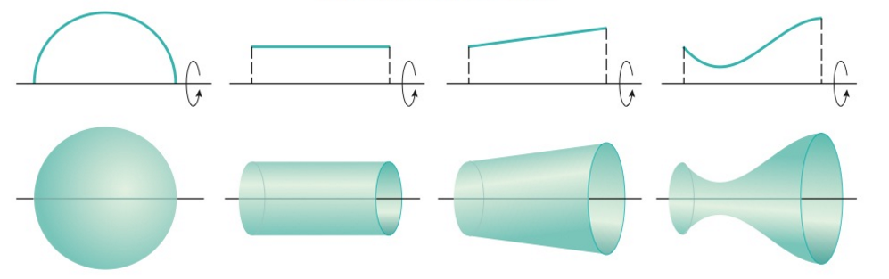

The Specifics:
Suppose we wish to revolve a curve C around an axis and find the surface area of the resulting solid.

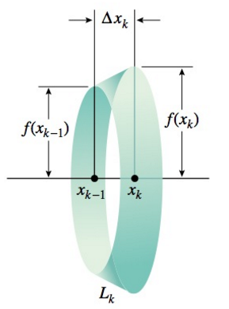
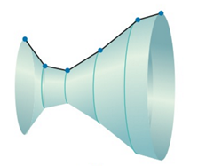
$$l$$
$$r_{1}$$
$$r_{2}$$

Definition: Suppose that is nonnegative and has a continuous derivative on , we define the surface area of the solid obtained by rotating the curve where about the x-axis as:

We note that:
where is the arc length differential (see section 2.4.1 for definition of arc length differential).

Thus, if the curve is described as where then the formula is:

Definition: Suppose that is nonnegative and has a continuous derivative on , we define the surface area of the solid obtained by rotating the curve where about the y-axis as:

Thus, if the curve is described as where then the formula is:

Note: In these definitions we are not able to put limits of integration on the integrals involving the arc length differential because we do not know limits on the s.
Example 1: Find the exact surface area of the figure obtained by rotating the curve where about the x-axis.

Example 2: Set up, but do not evaluate, an integral which yields the exact surface area of the figure obtained by rotating the curve where about the y-axis.

Example 3: Set up, but do not evaluate, an integral which yields the exact surface area of the figure obtained by rotating the curve where about the y-axis.

Example 4: Determine the exact area of the surface generated by revolving where about the x-axis.

